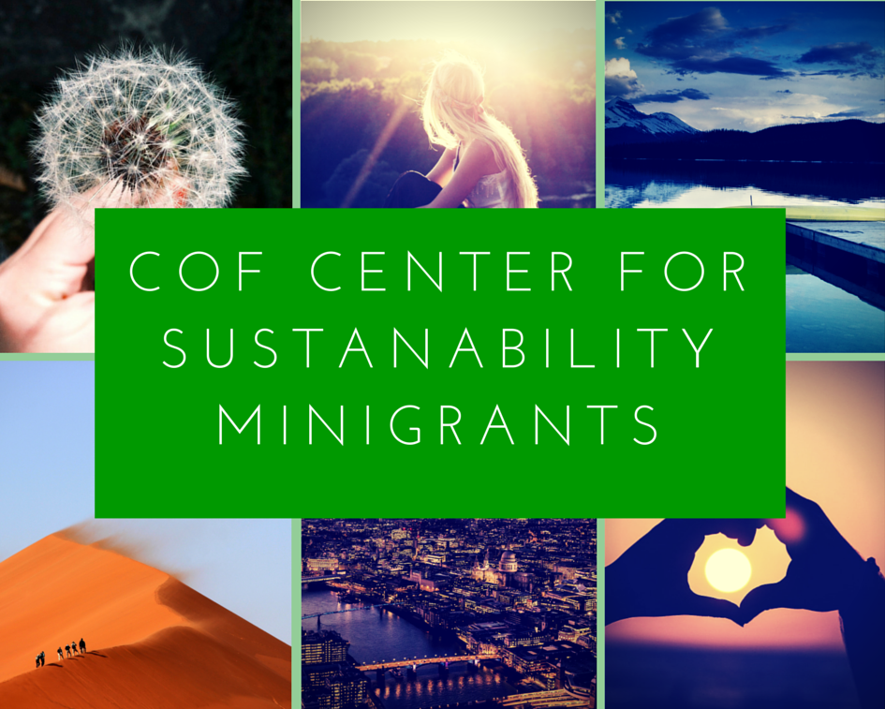
Six mini-grants of up to $500 available
Application deadline is December 1, 2017. Awards will be given during January Student Social.
The COF Center for Sustainability and Environment is pleased to offer an opportunity for students to apply for mini-grants in support of research, projects or initiatives supporting sustainability.
Projects will be highlighted at the 2018 Annual Muddy River Symposium, in COF publications and at the 2018 COF Earth Day Celebration.
All COF students are eligible to apply. Application information can be found at http://www.colleges-fenway.org/center-for-sustainability-and-the-environment/
COF Center for Sustainability and the Environment
Mini-grant Program

The COF Center for Sustainability and the Environment is pleased to offer our students the opportunity to apply for mini-grants in support of research, projects or initiatives that promote sustainability.

Projects granted will be widely promoted to the COF communities to recognize the importance of student led sustainability initiatives.

Public presentations will offer opportunities for the COF community to learn more about how to live and create sustainably.

Award: up to $500

Number of awards: 6

Application Deadline: December 1, 2017

Award announcement: January 2018

Project completion: Before or up to December 1, 2018

Grant expectations: The student or team of grantees must fulfill the following obligations by December 1, 2018
- Submit 3-5 images and any other documentation of the final project
- Present progress or final results of project at the Annual Muddy River Symposium in April 2018
- Write a blog post for the COF Center for Sustainability website (project proposal, midpoint review, or final project summary)
- Present the work to the COF community during the 2018 COF Earth Day Celebration

Eligibility: currently registered undergraduate, graduate, and certificate COF students

Proposal review will be conducted by faculty members of the Center for Sustainability and the Environment.

Application requirements:
- Be a current COF student(s).
- Prepare a brief proposal (max of 2 pages) describing the project methods and significance of the project or initiative.
- Prepare a detailed budget (see sample budget rubric attached) If this funding will be part of a larger budget, specify other funding and describe how COF funds will be spent).
- Prepare a timeline for project completion (see sample timeline rubric attached)
- Submit all proposal materials in one PDF to Anna Aguilera at Aguilera@simmons.edu
- Have a letter of support submitted electronically from a faculty advisor to Aguilera@simmons.edu
- Successful applicants will be required to write an article or blog post for the COF website, describing the proposed research or initiative.
- Present the results or progress of their project at the 2018 Annual Muddy River symposium.
- For more information, contact the COF Center for Sustainability Faculty Contact on your Campus
  - Emmanuel – Javier Marion Marionj@emmanuel.edu
  - MassArt – Jane Marsching Jane.marsching@massart.edu
  - MCPHS – Lana Dvorkin Camiel Lana.dvorkin@mcphs.edu
  - Simmons – Anna Aguilera Aguilera@simmons.edu
  - Wentworth – Jack Duggan Dugganj@wit.edu
  - Wheelock – Lisa Lobel Llobel@wheelock.edu
Proposal deadline is Dec 1, 2017.
Examples of previous projects include:
- Assessing the need and sustainability benefits of installing a water bottle refilling station on campus
- Begin a student recycling or reuse program (similar to the MassArt ReStore)
- Research focused on water quality of our local waterways, storm water runoff, increasing green spaces, building garden beds or green houses on campus.
- Innovative use of materials on campus
- Hosting a hive of urban bees on a campus rooftop
- Creating educational program for a project (similar to what WIT did with composting)
- Correct medication disposal educational program
- Evaluation of waste reduction with automatic utensil dispenser
- Development of an interactive map of a campus to showcase sustainability initiatives
- Creation of communal environment for studying and collaboration at the solar battery recharge station
- Building green wall
- Development of a medical device to be used with multi-dose inhalers to prevent waste of medications

Budget Requirements:

Please fill out this form with information about your budget.

1. A short paragraph detailing how/why the proposed materials/items will be used in the project

2.
 | Item and description……………..…… | Price ($) …… | Quantity | Subtotal
1
2
3
4
5
6
7
8
9
10
11
12
13
14
15
16
17
18
TOTAL

Timeline Requirements:

Please include a timeline for your project.

Include your goals for research, production, and presentation as per the guidelines of the mini-grant.

The following table can help you formulate goals and deadlines.

 | Goal | Amount of Time  to Complete | Deadline
1
2
3
4
5
6
7
8
9
10
11
12

